**Phase 1 project**

**Project Title: AIR QUALITY MONITORING**

**Project ID:** proj_223737_Team_3

**College:** Gnanamani College of Technology

**Branch:** B.Tech/Information Technology

**Year:** IIIrd year

**Air quality monitoring:**

An IoT-based air pollution monitoring system is an ideal solution that can provide real-time data and insights about the air quality in a particular area. An IoT based air pollution monitoring system consists of several hardware and software components that works together to collect and process data.

**Abstract:**

Air pollution became the major problem in the world. The world is getting polluted because of emission of dangerous gases into air such as CO2, SO2, NO2, and CO. These toxic gases are dissolved in air and cannot be predicted. Hence a tool is required to check the air quality. The air pollution can be monitor by using internet based devices like IoT. Internet of thing (IoT) devices can collect the data and based on data can analysis for prediction i.e. quality of air is good or not. Thus, the air quality of a particular area can be monitored using IOT based devices and sensors using Arduino/Raspberry Pi. The purpose of this research study is to understand Information on environmental variables and also allowing easy integration into any other type of internet-based architecture (IoT) which allows the use of sensors capable of collect information on sensors related to smart city environment measurements, with a view to provide data on which environmental pollution cab be reduced.

**Understand the problems:**

Air pollution is one of environmental issues that cannot be ignored. Inhaling pollutants for a long time causes damages in human health. Traditional air quality monitoring methods, such as building air quality monitoring stations, are typically expensive. This project is suitable for air quality monitoring in real time.Design a tool which will sense quality of air and display it in the form of percentage,Sense how much carbon mono-oxide(CO) is present in air and display in the form of percentage,Sense the temperature and display it in degree celcius.

**Design Thinking:**

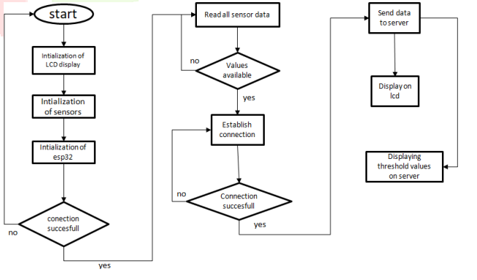

**Requirements:**

**Hardware required:**

* Arduino Uno R3
* Arduino cable
* MQ 135 gas sensor
* 16x2 LCD display
* 10k Potentiometer
* Jumper wires(male to male)
* Breadboard

**Software required:**

* Arduino IDE

**Team members:**

* K.Balachandar(620821205006)
* V.Jana(620821205020)
* S.Kathirvanan(620821205028)
* K.Pravinkumar(620821205041)
* S.Srikanth(620821205056)